**Trophic interaction models predict interactions across space, not food webs.**

Dominique Caron1,2, Ulrich Brose3,4, Miguel Lurgi5,6, F. Guillaume Blanchet2,7,8,9, Dominique Gravel2,7, Laura J. Pollock1,2

**Affiliations**

1 Department of Biology, McGill University, Montreal, QC, Canada

2 Quebec Centre for Biodiversity Sciences, Montreal, QC, Canada

3 German Centre for Integrative Biodiversity Research (iDiv) Halle-Jena-Leipzig, Leipzig, Germany

4 Institute of Biodiversity, Friedrich Schiller University Jena, Jena, Germany

5 Department of Biosciences, Swansea University, Singleton Park, SA2 8PP. UK.

6 Centre for Biodiversity Theory and Modelling, Theoretical and Experimental Ecology Station, CNRS, Moulis, 09200 France.

7 Département de biologie, Université de Sherbrooke, Sherbrooke, QC, Canada

8 Département de mathématiques, Université de Sherbrooke, Sherbrooke, QC, Canada

9 Département des sciences de la santé communautaire, Université de Sherbrooke, Sherbrooke, QC, Canada

**Corresponding author:** Dominique Caron, [dominique.caron@mail.mcgill.ca](mailto:dominique.caron@mail.mcgill.ca)

**Key Words:** ecological predictions; food web; model transferability; terrestrial vertebrates; trait matching; trophic interactions

**Abstract**

**Aim:** Trophic interactions are central to our understanding of essential ecosystem functions such as nutrient cycling and productivity as well as their stability. While empirical data on trophic interactions remains unavailable for most taxa in most ecosystems, predicting these interactions has become increasingly common. We aim at determining how far we can extrapolate with these trophic interaction models and how well can they recover higher level properties of food webs (species position and entire food web properties).

**Location:** Canada, Europe, Tanzania.

**Time period:** Current.

**Major taxa studied:** Terrestrial vertebrates

**Methods:** We use four trait-based models of trophic interactions, each calibrated on a different food web of terrestrial vertebrates (list them), to predict to the remaining food webs. We test how well predictions recover individual predator-prey pairs and higher level properties of food webs.

**Results:** We find that, given enough phylogenetic and environmental similarities between food webs, trait-based models predict most interactions and non-interactions correctly (AUC > 0.82) even in highly contrasting environment. However, network metrics were less well-predicted with predicted food webs being more connected, less modular, and having higher mean trophic levels.

**Main conclusions:** Trophic niche theory predicts that food webs vary through either changes in trait distributions and trait-matching relationships. Trait-based models can predict pools of potential interactions from reasonably similar food webs, suggesting that food webs vary spatially primarily through changes in trait distributions. We also highlight the need for methodological advances to simultaneously address trophic interactions and the structure of food webs across time and space.

**Introduction**

Many ecosystem functions (e.g., energy flows and material cycling) and community stability depend on the trophic relationships that link species within a community (Harvey et al. 2017). Despite the recognized importance of food webs in ecosystems over the last 80 years (Lindeman 1942), we still face major challenges to develop accurate descriptions of food webs. The lack of trophic interactions data across most locations and taxa (Poisot et al. 2021) lie at the core of the fundamental technical and practical challenges in food web ecology. Observing interactions is more challenging than observing species because two individuals need to be simultaneously detected while they are interacting (Jordano 2016), and the number of possible interactions webs grows quadratically with the number of species. Determining all possible interactions among species within a network is difficult even in species-poor ecosystems. Quantifying the strength and type (e.g. predator vs mutualism vs competition) of interactions, a common goal of ecological network studies, adds even more complexity to this already difficult problem.

A first step towards constructing food webs is to focus on a single type of interaction, predator-prey relationships, which are the most commonly recorded one, and have been shown to respond to a predictable set of neutral and niche processes (Morales-Castilla et al. 2015). A neutral model for trophic interactions suggests that the probability and strength of interactions respond only to the co-occurrences and abundances of species (Canard et al. 2012). Recent studies have shown however, that even if co-occurrence is a requirement for species to interact, it is not evidence for realized trophic interactions (Blanchet, Cazelles, and Gravel 2020). We must thus be careful when making assertions about trophic interactions based solely on co-occurence data. Niche theory predicts that the association between the functional traits of predators and those of their prey should improve predictions by identifying interactions that are feasible (Morales-Castilla et al. 2015). Trait-based models have been used to predict food webs in freshwater streams (Pomeranz et al. 2019), marine fishes (Albouy et al. 2014), terrestrial invertebrates (Laigle et al. 2018), and vertebrates (Caron et al. 2022; Fricke et al. 2022), among others. Phylogenetic relationships are also informative since interactions and species role (i.e., the position the species has in the food web) tend to be evolutionary conserved (Gómez, Verdú, and Perfectti 2010; Stouffer et al. 2012). Strydom et al. (2021) recently used a mammal phylogeny to map latent traits extracted from the European mammalian food web to predict its Canadian counterpart. Using this approach the authors were able to recover 90% of known trophic interactions among Canadian mammals without any prior information on the food web.

The question remains however, of how well can predictive models of trophic interactions transfer knowledge across different regions? In Strydom et al. (2021), it is challenging to know how inferences would transfer to more contrasting environments. Europe and Canada share similar bioclimatic conditions and, despite the little overlap in species, more than half of Canadian mammals have congeneric species in Europe. Another outstanding question is how well can trophic interaction models predict the underlying structure of the predator-prey relationships within a food web? Food web structure encompasses system-level properties such as connectivity or number of trophic levels, as well as species traits such as number of prey or their position within the food web. Most studies are aimed at predicting either the properties of food webs (e.g., Williams and Martinez 2008) or their interactions (e.g., Laigle et al. 2018; Pomeranz et al. 2019). They rarely assess how well predicted interactions can recover food web structure. Despite being able to recover most trophic interactions among European tetrapods, Caron et al. (2022) found that food web connectance was systematically overpredicted across Europe by 2-4 times. However, the authors did not explore how other food web properties (e.g., maximum trophic level, modularity) or species positions (e.g., trophic level, centrality) were predicted.

Here we test whether predictive models calibrated with a predator-prey network from one geographical region of the world can reliably predict interactions, species role and food web structure in similar ecosystems across the world. Using terrestrial vertebrate food webs from Europe, the Pyrenees, Northern Québec and Labrador, and the Serengeti we develop trait-based Bayesian hierarchical models to study how well can species interactions and food web properties be predicted across regions. We aim at (1) identifying the factors (i.e., geographic, environmental, functional, or phylogenetic distances) influencing the transferability of models across ecosystems and geographical regions, (2) predicting trophic roles across species and (3) quantifying the predicted food web properties.

**Methods**

*Food web data*

We extracted predator-prey interactions among terrestrial vertebrates (mammals, birds, amphibians and reptiles) from four well-resolved food webs (Table 1):

1. *Europe food web*: The food web comprising European tetrapods was assembled by Maiorano et al. (2020). The Europe food web contains the potential trophic interactions between all terrestrial vertebrates in Europe based on data from atlases, field guides, published papers, and expert knowledge. Maiorano et al. (2020) originally reported interactions between predators and their prey at different life-stage (eggs, larvae/young, or adult). In this study, we focused on interactions between predators and adult prey.
2. *Pyrenees food web*: The Pyrenees vertebrate food web was assembled independently from the European food web by Lurgi et al. (2012) who compiled all known interactions between vertebrate species in the southeastern Pyrenees mountain range. For this study, we excluded fish species.
3. *Northern Québec and Labrador food web*: The trophic tundra food web of Labrador and northern Quebec (Canada) was compiled by Berteaux et al. (2018). The Northern Québec and Labrador food web documents the presence (absence) of trophic relationships between all birds, mammals, and groups of plants (e.g., moss, ferns, grass) and arthropods (e.g., Lepidoptera, Diptera, Arachnida) whose distribution overlap Labrador and Quebec north of 50°N (Nunavik region). Trophic interactions were collated from a literature review, data from existing databases, and expert knowledge. For our study, we focused on the bird and mammal species (i.e. the vertebrates) of this network.
4. *Serengeti food web*: The Serengeti food web compiles all interactions between resource categories (e.g., seeds, shrubs, fruits and nectar), invertebrate groups (e.g., thrips, bees, moths, crickets), and vertebrate species in the Serengeti National Park (Tanzania) and was assembled from a literature review (de Visser, Freymann, and Olff 2011). The nodes of the original food webs are resource categories, or trophic groups including one or more invertebrate groups and vertebrate species. In this study, we focused on vertebrate species, and assumed that species within a trophic group share the same predator and prey species.

In all food webs, trophic interaction is a binary variable where 0 is the absence of predator-prey interaction and 1 is the presence of predator-prey interaction between two species (i.e., the predator could feed on the prey species). The species composition of the four food webs are different (Table 1). There are no amphibians or reptiles in Northern Québec and Labrador, the Pyrenees food web is dominated by birds (67%) and mammals (23%), with very few reptiles (8%), the European food web has a comparable number of reptiles (21%) and mammals (25%), and almost half (46%) of Serengeti food web are mammals. The Europe, Pyrenees, and Northern Québec and Labrador food webs all have comparable mean trophic levels (between 1.24 and 1.3) and connectance (between 0.02 and 0.05) compared to the Serengeti food web (mean trophic level: 1.61; connectance: 0.12). Most species are basal species (e.g., insectives, herbivores, piscivores) in Europe, Pyrenees and Northern Québec and Labrador, whereas many more species are eating terrestrial vertebrates (non-basal species) in the Serengeti.

*Trait data*

We extracted terrestrial vertebrate species ecological traits from the database compiled by Etard et al. (2020). This dataset combines species-level information from large freely available secondary trait databases (e.g., EltonTraits: Wilman et al. (2014), AmphiBIO: Oliveira et al. (2017)). Overall, the database includes traits for 6 990 amphibian, 11 634 bird, 5 380 mammal, and 10 612 reptile species. We extracted the body mass (mean: 11 kg; range: 1 g–4 220 kg), longevity (mean: 5 885 days; range: 91–46 386 days), litter or clutch size (mean: 5 885 offsprings; range: 1–20 000 offsprings), habitat breadth (mean: 10, range: 1-90), trophic level (3 levels: herbivore, omnivore, carnivore), activity time (2 categories: nocturnal, non-nocturnal) and habitat use (12 categories: forest, savanna, shrubland, grassland, wetland, rocky areas/cave/subterranean, desert, marine, marine/intertidal or coastal/supratidal, artificial, introduced vegetation) for species present in at least one of the four food webs of our study.

To match species in the trait databases to the species in the food webs, we standardized their names following the taxonomic backbone of the Global Biodiversity Information Facility (GBIF) using the function *name_backbone* from the package *rgbif* (Chamberlain et al. 2022) in the R statistical language (R Core Team 2022). In each food web, we excluded all species for which no taxonomic information or traits were available. We imputed missing traits using the MissForest algorithm (Stekhoven and Buehlmann 2012) for amphibians, birds, mammals and reptiles separately. MissForest first imputes all missing data with the mean (for quantitative variables) or the mode (for categorical variables). For each variable, MissForest then calibrates a random forest on the known data and predicts the missing data.

*Phylogeny data*

We used phylogeny data to measure how model transferability was influenced by phylogenetic relatedness. We used the published global phylogeny for birds (Jetz et al. 2012), amphibians (Jetz and Pyron 2018), squamates (Tonini et al. 2016), turtles (Thomson, Spinks, and Shaffer 2021), and mammals (Upham, Esselstyn, and Jetz 2019). All five phylogeny are dated and were built with molecular data. Species with missing molecular data in the birds, amphibians, squamates, and mammals phylogeny were imputed, whereas the turtles phylogeny only includes species for which molecular data was available (80% of all turtle species). We sampled 100 trees from the posterior of each phylogeny and calculated the mean cophenetic distance from these samples between all species of the four food webs. Following the recommendations by Letten & Cornwell (2015), we square root transformed cophenetic distances to better represent functional dissimilarity.

*Predictive models*

We calibrated a Bayesian hierarchical generalized linear model on each of the four food webs (Figure 1a.I). The response data are trophic interactions that we modelled as Bernoulli distributed. Because Caron et al. (2022) found that trait-interaction relationships vary between predator groups, we used the order of the predator as varying intercepts and slopes. For each model, we randomly drew 70% of the predator-prey interactions and an equal number of absence of interaction for calibration and used remaining data for validation. To make our results are robust to the random calibration-validation split, we compared the predictions made by ten random calibration subsets and ten random validation subsets for each models.

,

,

where is the occurrence of interaction between predator *j* and prey *i*, is the associated probability of interaction, and are the fixed intercept and slopes of the linear model, and and are the random intercepts and slopes for the order of predator *j*.

We used 13 trait-based predictors in the models: five predator traits (trophic level, body mass, habitat breadth, longevity, and clutch size), five prey traits (trophic level, body mass, habitat breadth, longevity, and clutch size), and three trait-match predictors (match in activity time, habitat use and body mass). Since the activity time trait is binary (nocturnal and non-nocturnal) in Etard et al. (2020), the activity time match is a binary variable where a one means the predator and the prey share the same activity time trait. Habitat match is calculated as the Jaccard similarity index between the habitat used by the prey and the predator across the 12 habitat categories available in the trait database. The Jaccard similarity index takes into account the overlap in habitat used by both species and how specialized they are to these shared habitats (e.g., the habitat match of two habitat specialists species sharing their only habitat category is higher than the habitat match of two habitat generalists sharing one of their respective habitat categories). Body mass match is the squared difference between the log-transformed body mass of the prey and the predator. We used the squared difference between log-transformed body mass because we expect predators to eat prey within a given body mass interval (small enough to be handled by the predator, but big enough to be profitable; Petchey et al. (2008)). We log-transformed body mass, longevity and clutch size, because we expect the probability of interaction to respond more linearly with relative change in these variables (e.g., increase of 10% of body mass) than absolute change (e.g., increase of 10 grams). We also scaled each continuous predictor (after transformation) by subtracting out the mean and dividing by two times the standard deviation, so that the coefficients of the scaled continuous predictors are directly comparable to coefficients of unscaled binary predictors (Gelman 2008).

We used weakly informative priors for the intercept and the slopes of each model. Fixed effects were drawn from a normal distribution with a mean of 0 and a standard deviation of 1. Random effects (intercepts and slopes) were drawn from normal distributions. We used a normal distribution with a mean of 0 and a standard deviation of 1 as prior for the mean and a Half-Cauchy distribution with a scale parameter of 5 as prior for the standard deviation of the random effects:

To fit the models, we ran four chains, each with 1000 warm-up iterations, followed by 1000 iterations for inference. We diagnosed convergence and adequacy with rank plots, posterior predictive checks, and we calculated the rank-normalized potential scale reduction factor on split chains for all runs (Vehtari et al. 2021; Appendix XX). We conducted the analyses using Stan (Carpenter et al. 2017) through the package *brms* in R (Bürkner 2017).

*Predicting species interactions*

To quantify model transferability, we used each model to predict the food web fitted with that model and that of the other regions considered (Figure 1a.II). For each possible predator-prey pair, we extracted the mean of the posterior as the probability of interaction, and the standard deviation of the posterior as the uncertainty around the predicted probability of interaction. When predicting the food web on which the model was calibrated (i.e., within food web predictions), we compared the predicted interaction probabilities to the validation subset of the food web. When predicting food webs other than the one on which the model was calibrated (i.e., between food web predictions), we compared the predicted interaction probabilities to the entire empirical food web. We measured performance with the area under the receiver operating characteristic curve (AUC; Hanley and McNeil 1982). AUC varies from 0 to 1 where 0.5 indicates that the model failed to rank interactions higher than absences of interactions (i.e., random predictions), and 1 indicates that the model systematically ranked interactions higher than non-interactions (i.e., perfect predictions). We also measured the area under the precision-recall curve (Davis and Goadrich 2006), and directly used the posterior draws to get distributions for the true positive rate, true negative rate, positive predictive value and negative predictive value (Appendix XX).

To explore factors influencing model transferability, we assessed the performance of models to predict each food webs using three distance measures: geographic distance, environmental dissimilarity, and phylogenetic relatedness. We measured geographic distance as the Euclidean distance between the polygon centroid delimiting the spatial domain of each food web. Environmental dissimilarity was quantified using all 19 bioclimatic variables in WorldClim (Hijmans 2021). We randomly drew 500 points within each polygon corresponding to the spatial domain of our food webs and extracted bioclimatic data for these points. We used the mean of each bioclimatic variables to calculate the bioclimatic centroid of each food web. We calculated environmental distance as the Euclidean distance between the food web bioclimatic centroids. We repeated this step 10 times (10 sets of 500 random points) to make sure the environmental distance estimates are robust to random sampling (Appendix X). To measure phylogenetic relatedness, we used the mean cophenetic distance to the nearest taxon of every species in the predicted food web. We averaged over all species in the predicted food web the cophenetic distance to the phylogenetically closest species in the food web used for calibration. This approach measures the amount of evolutionary history in the predicted food web undocumented by the food web the model was calibrated on.

Another test of the factors influencing model transferability focuses on analyzing predictive performance at the species level. For each combination of predicted food web models (i.e., curves in Figure 1), we measured how accurately the set of prey and predators of each species were predicted also using the AUC. We modelled species-specific performance in terms of how connected the focal species is and how distinct the focal species is to the species pool used to calibrate the predictive model. To do this, we used species normalized degree (number of interactions divided by the maximum possible number of interactions), the functional mean pairwise distance (Mouchet et al. 2010) and distance to nearest taxon (Tucker et al., 2017). Functional mean pairwise distance is the average Gower distance (Gower 1971) between the focal species and all species in the food web used for calibration. To calculate Gower distances, we used all traits available in Etard (2020) through the function *funct.dist* from the R package mFD (Magneville et al. 2022). Distance to nearest taxon was quantified as the cophenetic distance between the focal species and the closest relative in the species in the food web used for model calibration.

*Predicting species’ functional role*s

Next, we were interested in how well species functional roles were predicted by our models. The functional role of a species is determined by its position in the food web (Cirtwill et al. 2018), which we quantified using five metrics related to the position of the species within the food webs (number of prey, number of predators, betweenness, closeness, eigenvector centrality), two metrics related to their trophic position (trophic levels and omnivory), two module-based metrics (within-module degree and participation coefficient; Guimerà & Amaral, 2005), and the motif profile of each species (Stouffer et al. 2012)*.* We detail each metric, their relation to functional role, and how they were calculated in Appendix XX.

To measure how well species roles were predicted, we compared each species position metric in empirical food webs to the species position in predicted food webs. For predicted food webs, we measured each role metric on 100 samples of the posterior distribution of the entire food web with the mean as the best point estimate for the metric and the standard deviation as measure of uncertainty. For each combination of model, predicted food web, and species role metric, we fitted a linear regression between the predicted position and the empirical position. We used the coefficient of determination (R²) to measure how well species roles were predicted. We also explored prediction biases using the simple linear models’ coefficients. We expect an intercept of zero for perfect predictions of species role, and deviation from zero would suggest systematic bias across the range of the role metric. We expect a slope of one for perfect predictions. A slope less than one would suggest that the role metric of species at the lower range are overpredicted, whereas the role metric of species at the upper range are underpredicted (i.e., more homogeneous role across species than in the empirical food web). A slope greater than one would suggest the opposite (i.e., more heterogeneous role across species than in the empirical food web).

*Predicting food web properties*

Finally, we investigated how well the global properties of food webs were predicted. We selected a range of metrics commonly used to quantify food web structure and which have been shown to influence food web functioning and stability: connectance, mean trophic level, maximum trophic level, motifs distribution, food web diameter, number of clusters, and modularity (Vermaat, Dunne, and Gilbert 2009; Borrelli 2015). As for species position, we evaluated these properties on the empirical food webs and compared them to the properties predicted using the mean of 100 sample of the posterior food web prediction. We detail each metric, their relation to food web function, and how they were calculated in Appendix X.

**Results**

*Predicting trophic interactions*

For all food webs, trophic interactions were better predicted by the model calibrated on the same food web (within food web predictions) than by model calibrated on other food webs (between food web predictions; Table 2). For within food web predictions, AUC varied between 0.92 and 0.96. Model performance was also good (AUC > 0.82) for transfer between the Europe, Pyrenees, and Northern Québec and Labrador food webs. Models did not transfer as well from and to the Serengeti food web, but performance was still good (AUC > 0.75). The area under the precision-recall curve, true positive rate, true negative rate, positive predictive value, and negative predictive value were all positively correlated with AUC and showed the same overall pattern (Appendix X).

To explore the factors influencing the transferability of interaction models, we modelled their performance relative to the geographic, environmental, and phylogenetic distances between the calibrated and predicted food web (Figure 2). Overall, performance tended to decrease with environmental (direct effect estimate: -0.54, 95%CrI = [-0.96, -0.12]) and phylogenetic distance (direct effect estimate: -0.45, 95%CrI = [-0.84, -0.07]). Performance also decreased with geographic distance (total effect estimate: -0.56, 95%CrI = [-0.80, -0.30]), but not after controlling for phylogenetic and environmental distances (direct effect estimate: -0.06, 95%CrI = [-0.46, 0.34]).

We also identified the species for which the interactions were incorrectly predicted by between food web predictions. We modelled species-specific performance to the phylogenetic and functional distance between the focal species and the species pool used to train the models (Figure 3). As expected, species with phylogenetically close relatives in the species pool used for calibration were, on average, better predicted than distant relatives. Species-specific performance slightly decreased at low and intermediate phylogenetic distances, and then dropped significantly at large distances. Models calibrated and predicted across classes (e.g. mammals to amphibians) had the lowest performance as expected (Appendix X). This situation only occurs with the Northern Québec and Labrador model predicting the other three food webs as there are no amphibians or reptiles in Northern Québec and Labrador. Surprisingly, predictive performance remained qualitatively unchanged by functional distance. We also found that interactions of specialist (i.e., species with few interactions) and generalist species (i.e., species with many interactions) were, on average, better predicted than interactions of species of intermediate specialization (Figure 3c).

*Predicting species functional role*

We found significant variation in how well species trophic positions were predicted across models (Figure 4). Species roles were slightly better predicted by within food web predictions than by between food web predictions. Interestingly, some measures of centrality (betweenness and closeness) were not well predicted, whereas others (number of prey and predators, eigenvector centrality) were relatively well predicted.

We also found important biases in the predictions of species roles when we fitted linear regressions between species roles in predicted food webs to their roles in the empirical food webs. The number of prey, predators, trophic level, omnivory, and the frequency of motif positions tended to be similarly overestimated across species (slopes close to 1, and intercept greater than 0). For other measures such as eigenvector centrality, betweenness, closeness, and module-based roles, species had more similar values between predicted and empirical food webs (Appendix X, slopes less than 1).

*Predicting food web properties*

The majority of food web properties were not well predicted by our interaction models (Figure 5). Connectance, mean and max trophic levels, and the frequency of most motifs were overpredicted, whereas the number of clusters and modularity were slightly underpredicted. Mean and variance of relative errors were greater for between- compared to within-food web predictions. In general, predicted food webs were more connected, displayed a higher frequency of most motifs, and were less modular and with less basal species. This increased the trophic level of most species.

**Discussion**

Predictive models of trophic interactions have recently become central in filling knowledge gaps about how predators and prey interact across space and time. Here, we showed that trait-based trophic interaction models can predict interactions across ecosystems. We found that, given enough phylogenetic and environmental similarities between the system on which the model is calibrated and the system for which the predictions are made, models predicted most interactions reasonably well. Our results suggest that, for terrestrial vertebrate food webs, trait relationships driving interactions appear to be relatively general even in highly contrasting environments. Although models were successful at predicting interactions, they were less successful higher-level food web properties. We found systematic biases in the species position and food web properties predictions. Biases varied across metrics, but overall, the predicted food webs were better connected, less modular, had more trophic levels, and species were more equally connected. These higher-level properties of food webs were especially poorly predicted when making between food web predictions (i.e., knowledge transfer).

The trait-matching framework of trophic niche theory assumes that spatial variation in food webs arises through variation in the trait-matching rules driving interactions and the distribution of traits in different systems (Gravel, Albouy, and Thuiller 2016). Our ability to predict food web interactions across contrasting environment suggests that spatial food web variation is mainly driven by changes in the distribution of functional traits, and less so by the variation of trait-matching relationships. These are in line with previous results finding generalities in trait-interactions relationships across European bioregions (Caron et al. 2022), the predator-prey body-size ratios within habitat, predator, and prey types (Brose et al. 2006), and the trait-interactions relationships in soil invertebrates across three forest areas in Germany (Laigle et al. 2018). Given that trait-matching rules driving species interactions seem general in reasonably similar environments, it should be possible to use data from well-studied areas to predict interactions in areas we know very little about or forecast (and hindcast) food webs given new trait distributions. Strydom et al. (2021) also found that latent trait models could accurately transfer knowledge through phylogenetic relationships. In the future, different predictors (e.g., trait-based models, phylogeny-based models), and models (e.g., linear models, machine learning) could be combined into ensemble models. Ensemble models have the potential to make better predictions by cancelling the noise created by the specific data and models (Araújo and New 2007). However, model comparison studies are needed since ensemble models do not always outperform individual models (Hao et al. 2020).

We also highlighted a major limitation of trophic interaction models: trophic interaction models predict interactions, not food webs. Even if most interactions and absences of interactions are well predicted (high true positive and negative rates), there are much more absences of interactions to predict than presences in real food webs (low connectance). This might explain why our models systematically overpredicted the number of interactions (number of prey and predators) across species (Appendix X). This bias probably propagated through the food webs, explaining why the centrality of species was more evenly distributed, and the predicted food webs were more connected, less modular, and with higher trophic levels.

The structural properties of food webs (i.e., connectance, number of trophic levels, modularity) influence the stability, invasibility, and productivity of ecosystems (Duffy et al. 2007; Wang and Brose 2018; Lurgi et al. 2014), whereas the position of species within food webs determine their functional role, and can help identify keystone species and prevent cascading effects of extinction (Cirtwill et al. 2018; Estes et al. 2011). Here, predicting individual links failed to predict higher-level properties, suggesting that there are constraints acting on the structures of food webs that trophic interaction models cannot capture. Spatial and temporal variation of ecological network structure has gained a lot of interest recently (Baiser et al. 2019; Gravel et al. 2019). Because sampling interactions at large scales is difficult, predictions by interaction models could help to investigate the variation of interactions and network structures simultaneously (e.g., Albouy et al., 2014). This would be possible only if the biases in predicted network structure are constant across the gradient of interest. Given our results, testing this assumption should be necessary to robustly test the variation in network structure.

Correcting biases in higher-level property predictions is possibly an opportunity to improve species interaction predictions. In species distribution models, methods are already developed to use biases in higher-level properties (e.g., species richness) to correct distribution predictions (e.g., Leung et al., 2019). These models correct systematic biases in predictions similar to those we found in our study. Therefore, methods that would combine predictions of interactions and networks have the potential to provide better food web predictions. Different models can predict the number of links that we expect from the number of species (MacDonald, Banville, and Poisot 2020). With the number of links and species, structural food web models can predict the probability distribution of many food web properties (Williams and Martinez 2008). Information on probable food web structure could be used to correct posterior predictive distributions of species interactions.

Our study suffers from a few limitations that if overcome can move us closer to a comprehensive framework for ecological interactions and networks prediction. First, we used four food webs of terrestrial vertebrates. Although there is no clear *a priori* reason not to be applicable in other systems, our results are unlikely to be general across all taxa and types of interactions. We don’t know any other test of interaction model transferability, but it would be interesting to investigate if our results hold for systems where trait-matching relationships are stronger or weaker. The exclusion of non-terrestrial vertebrates (e.g., plants, invertebrates, parasites) also influence the empirical and predicted species role and food web properties. For example, the first trophic levels in our food webs were not primary producers, but species not feeding on terrestrial vertebrates (e.g., herbivores, invertivores). Second, the food webs we used are potential and binary food webs. Trait-matching models predict the probabilities that a species could eat another species given they are encountering. Additional data, such as co-occurrence and abundance data, are needed to make predictions of realized and quantitative interactions. Finally, due to the scarcity of food web data, we only had four food webs to work with. This means we only had four sets of within food web predictions, and 12 sets of between food web predictions. This explains the large uncertainty for some of our results (e.g., Figure 2). Despite the low sample size, we still detected significant relationship between model transferability and geographic, phylogenetic, and environmental distances.

Overall, we found that trait-based interaction models can transfer knowledge relatively well given enough phylogenetic and environmental similarities between systems. These models can predict pools of potential interactions even in contrasting environments, suggesting that changes in food webs are mainly explain by changes in trait distribution, and less by changes in the trait-interaction relationships. However, the resulting food webs should be viewed as a preliminary set of interactions, asking for refinement since the structure and trophic positions of species are not correctly predicted. These refinements could take the form of bias correction methods using predictions of higher-level food web properties, combination of predictions to other types of data (e.g.,, expert knowledge, co-occurrences, abundances), or combination of types of models (e.g., trait-matching, phylogenetic matching, machine learning). Such methodological advancements would allow better prediction of both interactions and food webs across space and time, which in turn, play a large role in filling the large knowledge gaps on how species interact and allow to investigate how global changes may impact ecosystems (Albouy et al. 2014; Fricke et al. 2022).

**Acknowledgements**

**Author contributions**

**References**

Albouy, Camille, Laure Velez, Marta Coll, Francesco Colloca, François Le Loc’h, David Mouillot, and Dominique Gravel. 2014. “From Projected Species Distribution to Food-Web Structure under Climate Change.” *Global Change Biology* 20 (3): 730–41. https://doi.org/10.1111/gcb.12467.

Araújo, Miguel B., and Mark New. 2007. “Ensemble Forecasting of Species Distributions.” *Trends in Ecology & Evolution* 22 (1): 42–47. https://doi.org/10.1016/j.tree.2006.09.010.

Baiser, Benjamin, Dominique Gravel, Alyssa R. Cirtwill, Jennifer A. Dunne, Ashkaan K. Fahimipour, Luis J. Gilarranz, Joshua A. Grochow, et al. 2019. “Ecogeographical Rules and the Macroecology of Food Webs.” *Global Ecology and Biogeography* 28 (9): 1204–18. https://doi.org/10.1111/geb.12925.

Berteaux, Dominique, Pascal Ropars, and Nicolas Casajus. 2018. “Toundra Nunavik : Matrice Des Relations Trophiques Entre Espèces Du Labrador et Du Québec Nordique, v. 1.0 (1980-2010).” *Nordicana D36*. https://doi.org/10.5885/45555CE-DA1FF11FA4254703.

Blanchet, F. Guillaume, Kevin Cazelles, and Dominique Gravel. 2020. “Co-Occurrence Is Not Evidence of Ecological Interactions.” *Ecology Letters* 23 (7): 1050–63. https://doi.org/10.1111/ele.13525.

Borrelli, Jonathan J. 2015. “Selection against Instability: Stable Subgraphs Are Most Frequent in Empirical Food Webs.” *Oikos* 124 (12): 1583–88. https://doi.org/10.1111/oik.02176.

Brose, Ulrich, Tomas Jonsson, Eric L. Berlow, Philip Warren, Carolin Banasek-Richter, Louis-Félix Bersier, Julia L. Blanchard, et al. 2006. “Consumer–Resource Body-Size Relationships in Natural Food Webs.” *Ecology* 87 (10): 2411–17. https://doi.org/10.1890/0012-9658(2006)87[2411:CBRINF]2.0.CO;2.

Bürkner, Paul-Christian. 2017. “**Brms** : An *R* Package for Bayesian Multilevel Models Using *Stan*.” *Journal of Statistical Software* 80 (1). https://doi.org/10.18637/jss.v080.i01.

Canard, Elsa, Nicolas Mouquet, Lucile Marescot, Kevin J. Gaston, Dominique Gravel, and David Mouillot. 2012. “Emergence of Structural Patterns in Neutral Trophic Networks.” *PLOS ONE* 7 (8): e38295. https://doi.org/10.1371/journal.pone.0038295.

Caron, Dominique, Luigi Maiorano, Wilfried Thuiller, and Laura J. Pollock. 2022. “Addressing the Eltonian Shortfall with Trait‐based Interaction Models.” Edited by Jonathan Chase. *Ecology Letters*, January, ele.13966. https://doi.org/10.1111/ele.13966.

Carpenter, Bob, Andrew Gelman, Matthew D. Hoffman, Daniel Lee, Ben Goodrich, Michael Betancourt, Marcus Brubaker, Jiqiang Guo, Peter Li, and Allen Riddell. 2017. “*Stan* : A Probabilistic Programming Language.” *Journal of Statistical Software* 76 (1). https://doi.org/10.18637/jss.v076.i01.

Chamberlain, Scott, Vijay Barve, Dan Mcglinn, Damiano Oldoni, Peter Desmet, Laurens Geffert, and Karthik Ram. 2022. “Rgbif: Interface to the Global Biodiversity Information Facility API.” Manual. https://CRAN.R-project.org/package=rgbif.

Cirtwill, Alyssa R., Giulio Valentino Dalla Riva, Marilia P. Gaiarsa, Malyon D. Bimler, E. Fernando Cagua, Camille Coux, and D. Matthias Dehling. 2018. “A Review of Species Role Concepts in Food Webs.” *Food Webs* 16 (September): e00093. https://doi.org/10.1016/j.fooweb.2018.e00093.

Davis, Jesse, and Mark Goadrich. 2006. “The Relationship between Precision-Recall and ROC Curves.” In *Proceedings of the 23rd International Conference on Machine Learning - ICML ’06*, 233–40. Pittsburgh, Pennsylvania: ACM Press. https://doi.org/10.1145/1143844.1143874.

Duffy, J. Emmett, Bradley J. Cardinale, Kristin E. France, Peter B. McIntyre, Elisa Thébault, and Michel Loreau. 2007. “The Functional Role of Biodiversity in Ecosystems: Incorporating Trophic Complexity.” *Ecology Letters* 10 (6): 522–38. https://doi.org/10.1111/j.1461-0248.2007.01037.x.

Estes, James A., John Terborgh, Justin S. Brashares, Mary E. Power, Joel Berger, William J. Bond, Stephen R. Carpenter, et al. 2011. “Trophic Downgrading of Planet Earth.” *Science* 333 (6040): 301–6. https://doi.org/10.1126/science.1205106.

Etard, Adrienne, Sophie Morrill, and Tim Newbold. 2020. “Global Gaps in Trait Data for Terrestrial Vertebrates.” *Global Ecology and Biogeography* 29 (12): 2143–58. https://doi.org/10.1111/geb.13184.

Fricke, Evan C., Chia Hsieh, Owen Middleton, Daniel Gorczynski, Caroline D. Cappello, Oscar Sanisidro, John Rowan, Jens-Christian Svenning, and Lydia Beaudrot. 2022. “Collapse of Terrestrial Mammal Food Webs since the Late Pleistocene.” *Science* 377 (6609): 1008–11. https://doi.org/10.1126/science.abn4012.

Gelman, Andrew. 2008. “Scaling Regression Inputs by Dividing by Two Standard Deviations.” *Statistics in Medicine* 27 (15): 2865–73. https://doi.org/10.1002/sim.3107.

Gómez, José M., Miguel Verdú, and Francisco Perfectti. 2010. “Ecological Interactions Are Evolutionarily Conserved across the Entire Tree of Life.” *Nature* 465 (7300): 918–21. https://doi.org/10.1038/nature09113.

Gower, J. C. 1971. “A General Coefficient of Similarity and Some of Its Properties.” *Biometrics* 27 (4): 857–71. https://doi.org/10.2307/2528823.

Gravel, Dominique, Camille Albouy, and Wilfried Thuiller. 2016. “The Meaning of Functional Trait Composition of Food Webs for Ecosystem Functioning.” *Philosophical Transactions of the Royal Society B: Biological Sciences* 371 (1694): 20150268. https://doi.org/10.1098/rstb.2015.0268.

Gravel, Dominique, Benjamin Baiser, Jennifer A. Dunne, Jens-Peter Kopelke, Neo D. Martinez, Tommi Nyman, Timothée Poisot, et al. 2019. “Bringing Elton and Grinnell Together: A Quantitative Framework to Represent the Biogeography of Ecological Interaction Networks.” *Ecography* 42 (3): 401–15. https://doi.org/10.1111/ecog.04006.

Guimerà, Roger, and Luís A. Nunes Amaral. 2005. “Cartography of Complex Networks: Modules and Universal Roles.” *Journal of Statistical Mechanics: Theory and Experiment* 2005 (02): P02001. https://doi.org/10.1088/1742-5468/2005/02/P02001.

Hanley, J A, and B J McNeil. 1982. “The Meaning and Use of the Area under a Receiver Operating Characteristic (ROC) Curve.” *Radiology* 143 (1): 29–36. https://doi.org/10.1148/radiology.143.1.7063747.

Hao, Tianxiao, Jane Elith, José J. Lahoz-Monfort, and Gurutzeta Guillera-Arroita. 2020. “Testing Whether Ensemble Modelling Is Advantageous for Maximising Predictive Performance of Species Distribution Models.” *Ecography* 43 (4): 549–58. https://doi.org/10.1111/ecog.04890.

Harvey, Eric, Isabelle Gounand, Colette L. Ward, and Florian Altermatt. 2017. “Bridging Ecology and Conservation: From Ecological Networks to Ecosystem Function.” *Journal of Applied Ecology* 54 (2): 371–79. https://doi.org/10.1111/1365-2664.12769.

Hijmans, Robert J. 2021. “Raster: Geographic Data Analysis and Modeling.” Manual. https://CRAN.R-project.org/package=raster.

Jetz, W., G. H. Thomas, J. B. Joy, K. Hartmann, and A. O. Mooers. 2012. “The Global Diversity of Birds in Space and Time.” *Nature* 491 (7424): 444–48. https://doi.org/10.1038/nature11631.

Jetz, Walter, and R. Alexander Pyron. 2018. “The Interplay of Past Diversification and Evolutionary Isolation with Present Imperilment across the Amphibian Tree of Life.” *Nature Ecology & Evolution* 2 (5): 850–58. https://doi.org/10.1038/s41559-018-0515-5.

Jordano, Pedro. 2016. “Sampling Networks of Ecological Interactions.” *Functional Ecology* 30 (12): 1883–93. https://doi.org/10.1111/1365-2435.12763.

Laigle, Idaline, Isabelle Aubin, Christoph Digel, Ulrich Brose, Isabelle Boulangeat, and Dominique Gravel. 2018. “Species Traits as Drivers of Food Web Structure.” *Oikos* 127 (2): 316–26. https://doi.org/10.1111/oik.04712.

Letten, Andrew D., and William K. Cornwell. 2015. “Trees, Branches and (Square) Roots: Why Evolutionary Relatedness Is Not Linearly Related to Functional Distance.” *Methods in Ecology and Evolution* 6 (4): 439–44. https://doi.org/10.1111/2041-210X.12237.

Leung, Brian, Emma J. Hudgins, Anna Potapova, and Maria C. Ruiz-Jaen. 2019. “A New Baseline for Countrywide α-Diversity and Species Distributions: Illustration Using >6,000 Plant Species in Panama.” *Ecological Applications* 29 (3): e01866. https://doi.org/10.1002/eap.1866.

Lindeman, Raymond L. 1942. “The Trophic-Dynamic Aspect of Ecology.” *Ecology* 23 (4): 399–417. https://doi.org/10.2307/1930126.

Lurgi, Miguel, Núria Galiana, Bernat C. López, Lucas N. Joppa, and José M. Montoya. 2014. “Network Complexity and Species Traits Mediate the Effects of Biological Invasions on Dynamic Food Webs.” *Frontiers in Ecology and Evolution* 2. https://www.frontiersin.org/articles/10.3389/fevo.2014.00036.

Lurgi, Miguel, Bernat C. López, and José M. Montoya. 2012. “Climate Change Impacts on Body Size and Food Web Structure on Mountain Ecosystems.” *Philosophical Transactions of the Royal Society B: Biological Sciences* 367 (1605): 3050–57. https://doi.org/10.1098/rstb.2012.0239.

MacDonald, Arthur Andrew Meahan, Francis Banville, and Timothée Poisot. 2020. “Revisiting the Links-Species Scaling Relationship in Food Webs.” *Patterns* 1 (7). https://doi.org/10.1016/j.patter.2020.100079.

Magneville, Camille, Nicolas Loiseau, Camille Albouy, Nicolas Casajus, Thomas Claverie, Arthur Escalas, Fabien Leprieur, Eva Maire, David Mouillot, and Sébastien Villéger. 2022. “MFD: An R Package to Compute and Illustrate the Multiple Facets of Functional Diversity.” *Ecography* 2022 (1). https://doi.org/10.1111/ecog.05904.

Maiorano, Luigi, Alessandro Montemaggiori, Gentile Francesco Ficetola, Louise O’Connor, and Wilfried Thuiller. 2020. “TETRA‐EU 1.0: A Species‐level Trophic Metaweb of European Tetrapods.” Edited by Allen Hurlbert. *Global Ecology and Biogeography*, June, geb.13138. https://doi.org/10.1111/geb.13138.

Morales-Castilla, Ignacio, Miguel G. Matias, Dominique Gravel, and Miguel B. Araújo. 2015. “Inferring Biotic Interactions from Proxies.” *Trends in Ecology & Evolution* 30 (6): 347–56. https://doi.org/10.1016/j.tree.2015.03.014.

Mouchet, Maud A., Sébastien Villéger, Norman W. H. Mason, and David Mouillot. 2010. “Functional Diversity Measures: An Overview of Their Redundancy and Their Ability to Discriminate Community Assembly Rules.” *Functional Ecology* 24 (4): 867–76. https://doi.org/10.1111/j.1365-2435.2010.01695.x.

Oliveira, Brunno Freire, Vinícius Avelar São-Pedro, Georgina Santos-Barrera, Caterina Penone, and Gabriel C. Costa. 2017. “AmphiBIO, a Global Database for Amphibian Ecological Traits.” *Scientific Data* 4 (1): 1–7. https://doi.org/10.1038/sdata.2017.123.

Petchey, O. L., A. P. Beckerman, J. O. Riede, and P. H. Warren. 2008. “Size, Foraging, and Food Web Structure.” *Proceedings of the National Academy of Sciences* 105 (11): 4191–96. https://doi.org/10.1073/pnas.0710672105.

Poisot, Timothée, Gabriel Bergeron, Kevin Cazelles, Tad Dallas, Dominique Gravel, Andrew MacDonald, Benjamin Mercier, Clément Violet, Steve Vissault, and Daniel Chapman. 2021. “Global Knowledge Gaps in Species Interaction Networks Data.” *Journal of Biogeography*, April, jbi.14127. https://doi.org/10.1111/jbi.14127.

Pomeranz, Justin P. F., Ross M. Thompson, Timothée Poisot, and Jon S. Harding. 2019. “Inferring Predator–Prey Interactions in Food Webs.” *Methods in Ecology and Evolution* 10 (3): 356–67. https://doi.org/10.1111/2041-210X.13125.

R Core Team. 2022. *R: A Language and Environment for Statistical Computing*. Vienna, Austria: R Foundation for Statistical Computing. https://www.R-project.org/.

Stekhoven, Daniel J., and Peter Buehlmann. 2012. “MissForest - Non-Parametric Missing Value Imputation for Mixed-Type Data.” *Bioinformatics (Oxford, England)* 28 (1): 112–18.

Stouffer, Daniel B., Marta Sales-Pardo, M. Irmak Sirer, and Jordi Bascompte. 2012. “Evolutionary Conservation of Species’ Roles in Food Webs.” *Science* 335 (6075): 1489–92. https://doi.org/10.1126/science.1216556.

Strydom, Tanya, Salomé Bouskila, Francis Banville, Cerres Barros, Dominique Caron, Maxwell J. Farrell, Marie-Josée Fortin, et al. 2021. “Food Web Reconstruction through Phylogenetic Transfer of Low-Rank Network Representation.” EcoEvoRxiv. https://doi.org/10.32942/osf.io/y7sdz.

Thomson, Robert C., Phillip Q. Spinks, and H. Bradley Shaffer. 2021. “A Global Phylogeny of Turtles Reveals a Burst of Climate-Associated Diversification on Continental Margins.” *Proceedings of the National Academy of Sciences* 118 (7): e2012215118. https://doi.org/10.1073/pnas.2012215118.

Tonini, João Filipe Riva, Karen H. Beard, Rodrigo Barbosa Ferreira, Walter Jetz, and R. Alexander Pyron. 2016. “Fully-Sampled Phylogenies of Squamates Reveal Evolutionary Patterns in Threat Status.” *Biological Conservation*, Advancing reptile conservation: Addressing knowledge gaps and mitigating key drivers of extinction risk, 204 (December): 23–31. https://doi.org/10.1016/j.biocon.2016.03.039.

Tucker, Caroline M., Marc W. Cadotte, Silvia B. Carvalho, T. Jonathan Davies, Simon Ferrier, Susanne A. Fritz, Rich Grenyer, et al. 2017. “A Guide to Phylogenetic Metrics for Conservation, Community Ecology and Macroecology.” *Biological Reviews* 92 (2): 698–715. https://doi.org/10.1111/brv.12252.

Upham, Nathan S., Jacob A. Esselstyn, and Walter Jetz. 2019. “Inferring the Mammal Tree: Species-Level Sets of Phylogenies for Questions in Ecology, Evolution, and Conservation.” *PLOS Biology* 17 (12): e3000494. https://doi.org/10.1371/journal.pbio.3000494.

Vehtari, Aki, Andrew Gelman, Daniel Simpson, Bob Carpenter, and Paul-Christian Bürkner. 2021. “Rank-Normalization, Folding, and Localization: An Improved Rˆ for Assessing Convergence of MCMC (with Discussion).” *Bayesian Analysis* 16 (2): 667–718. https://doi.org/10.1214/20-BA1221.

Vermaat, Jan E., Jennifer A. Dunne, and Alison J. Gilbert. 2009. “Major Dimensions in Food-Web Structure Properties.” *Ecology* 90 (1): 278–82. https://doi.org/10.1890/07-0978.1.

Visser, Sara N. de, Bernd P. Freymann, and Han Olff. 2011. “The Serengeti Food Web: Empirical Quantification and Analysis of Topological Changes under Increasing Human Impact.” *Journal of Animal Ecology* 80 (2): 484–94. https://doi.org/10.1111/j.1365-2656.2010.01787.x.

Wang, Shaopeng, and Ulrich Brose. 2018. “Biodiversity and Ecosystem Functioning in Food Webs: The Vertical Diversity Hypothesis.” *Ecology Letters* 21 (1): 9–20. https://doi.org/10.1111/ele.12865.

Williams, Richard J., and Neo D. Martinez. 2008. “Success and Its Limits among Structural Models of Complex Food Webs.” *Journal of Animal Ecology* 77 (3): 512–19.

Wilman, Hamish, Jonathan Belmaker, Jennifer Simpson, Carolina de la Rosa, Marcelo M. Rivadeneira, and Walter Jetz. 2014. “EltonTraits 1.0: Species-Level Foraging Attributes of the World’s Birds and Mammals.” *Ecology* 95 (7): 2027–2027. https://doi.org/10.1890/13-1917.1.

Table 1: *Summary of properties of the food webs used in this study after excluding species for which no match was found in the GBIF Backbone Taxonomy or was not documented in the trait database. Trait coverage is the percentage of traits documented in Etard et al. (2020) before imputing missing traits.*

Table 2:Food webs are better predicted by their own calibrated model. Area under the receiver operating curve (AUC) of each model predicting every food web.

Figure *1:* **Trophic interactions model transferability analysis workflow.** We calibrated trophic interaction model on using each food web considered in this study separately (panel a.I). We validated the four models on a validation subset for within-food web predictions (not shown in the figure), and the entire set of food webs for between-food web predictions (panel a.II). Panel (a) shows an example workflow for the between food web predictions. Panel (b) is a map of the spatial domain of each food web. The 12 curves are the model-food web pairs for between food web predictions. The within food web predictions are not shown in the figure. Bar plots show the proportion of amphibians (green), birds (yellow), mammals (purple), and reptiles (red) in each food web.

Figure 2: **Transferability of predictive models.** Points are the predictive performance (area under the receiver operating curve) of the sixteen combination of model-food web prediction (Table 2). The trend lines are the median effects with their 95% credible interval of geographic, environmental, and phylogenetic distances on predictive performance. Shown are the direct effect of geographic distance (controlling for environmental and phylogenetic distances), and the direct (controlling for geographic distance) effects of environmental and phylogenetic distances.

Figure *3*: ***Predicting species interactions****. Performance of the model calibrated on each food web to predict the interactions of species in the other food webs. Each point is the performance to predict the prey and predators of a single species. The trend lines are the median effects with their 95% credible interval of distance to the nearest taxon, mean functional pairwise distance, and normalized degree on predictive performance.*

*Figure 4:* ***Predicting species functional role****. The variance in predicted trophic positions explained by the empirical trophic position. From left to right, the figure shows the number of prey, number of predators, betweenness, closeness, eigenvector centrality, within-module degree, participation coefficient, times the species is at a specific position in the linear chain, intraguild predatrion, direct competition, and apparent competition motifs. The horizontal lines are the R² for each role, model, and food web predicted combination. White dots are the mean R² with for within food web predictions. Black dots are the mean R² for across food web predictions.*

*Figure 5:* ***Predicting global food web properties****. The relative error of the predicted food web properties. Relative error is the difference between the predicted and empirical estimates divided by the empirical estimate. From left to right, the figure shows the relative error for connectance, maximum trophic level, mean trophic level, number of clusters, modularity, diameter, number of linear chain, intraguild predation, direct competition, and apparent competition motifs. Horizontal lines are the relative errors for each property, model, and food web predicted combination. White dots are the mean relative errors for within- and black dots are the mean relative errors for between-food web predictions.*

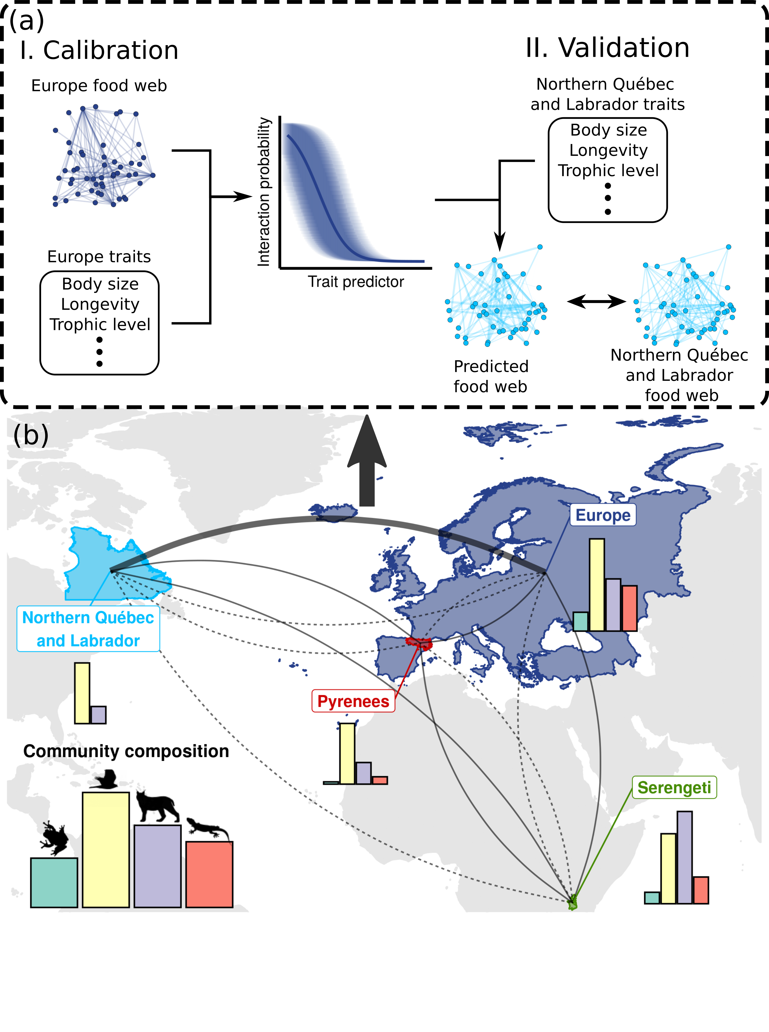Figure 1: **Trophic interactions model transferability analysis workflow.**

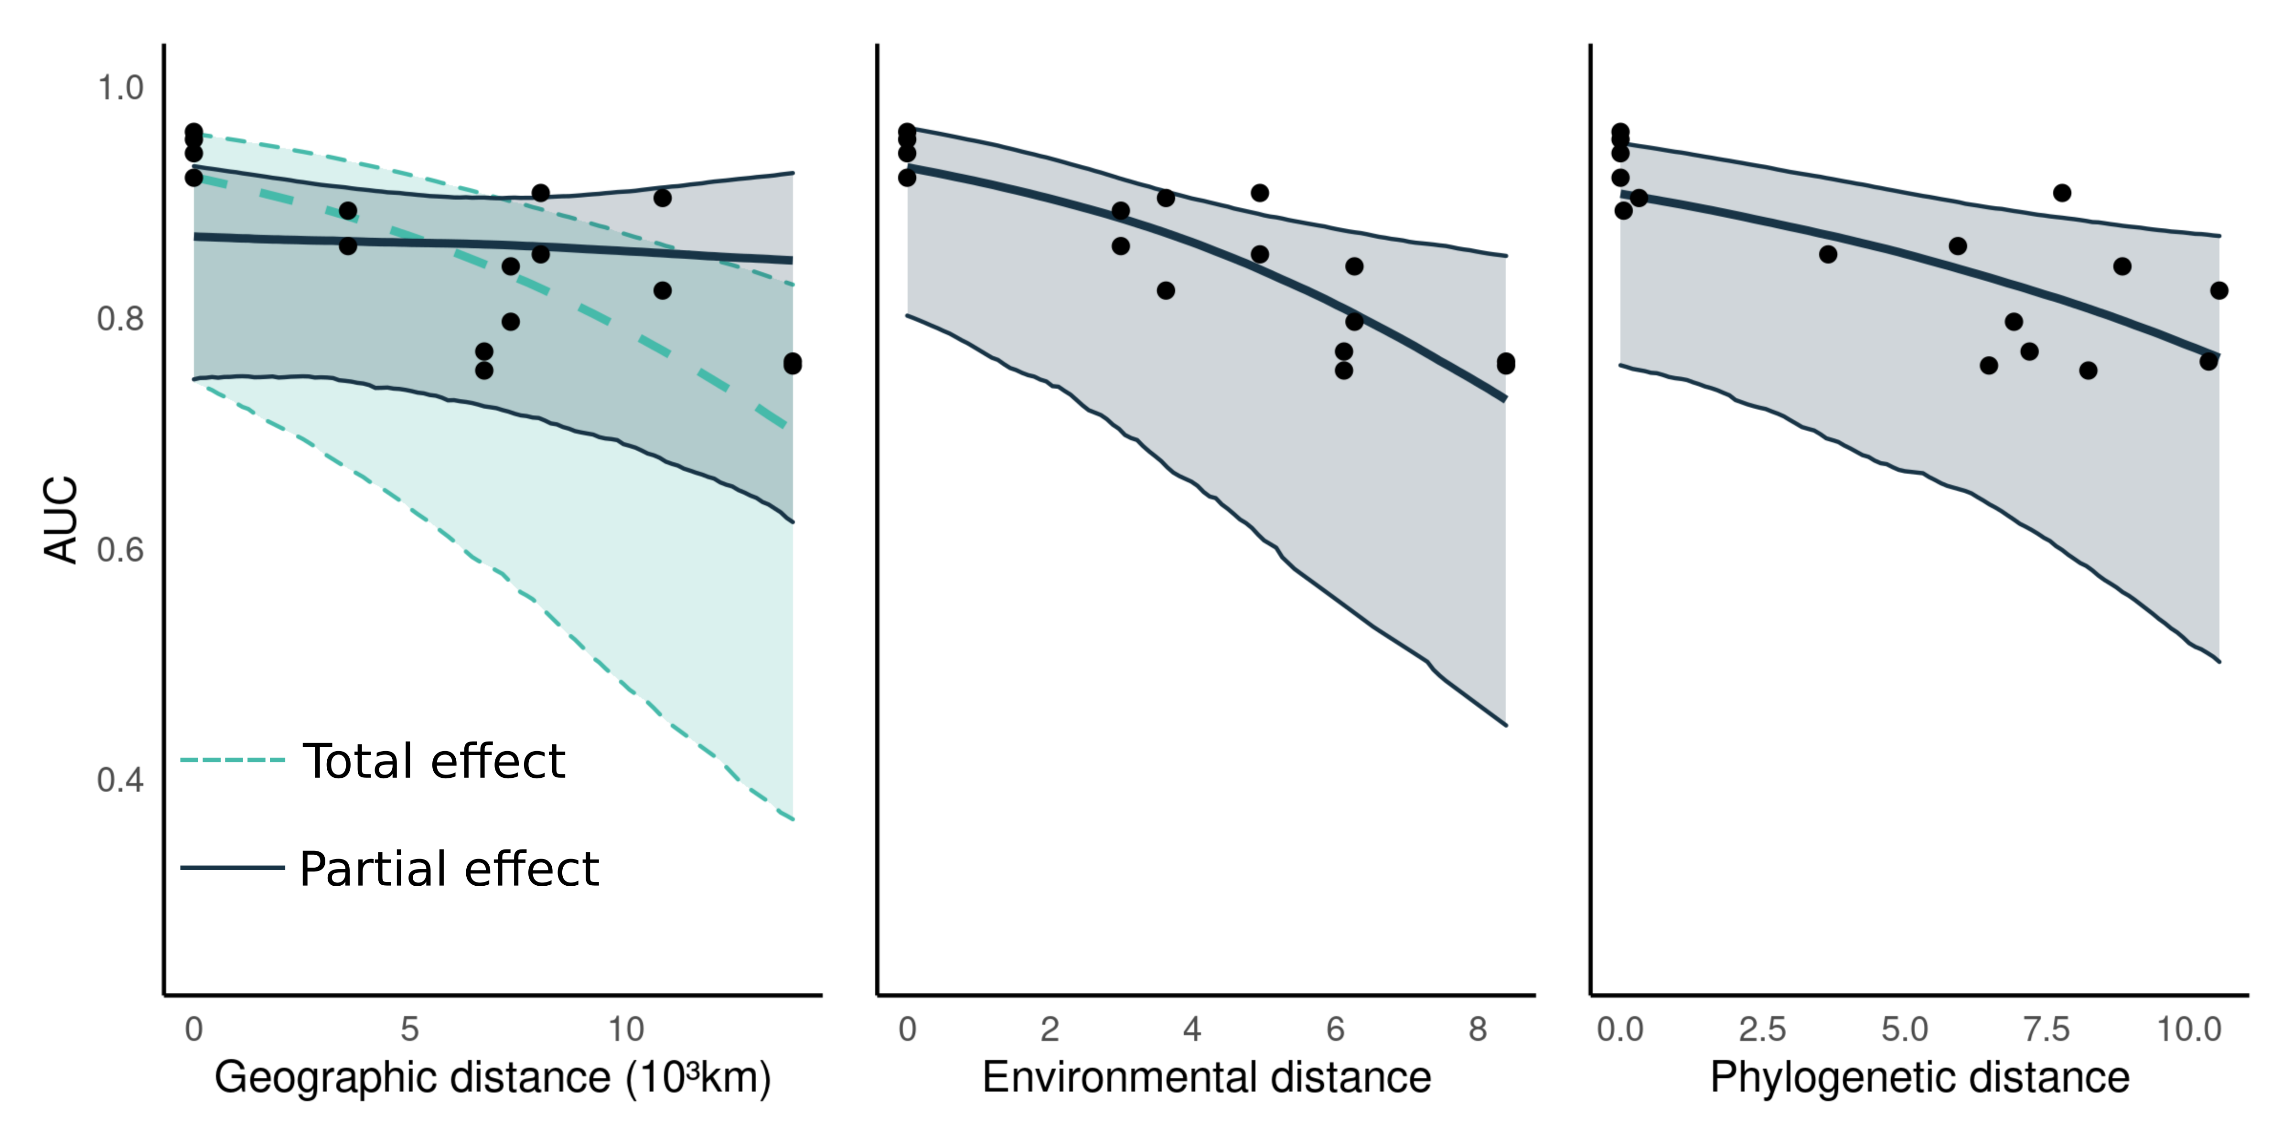Figure 2: **Transferability of predictive models.**

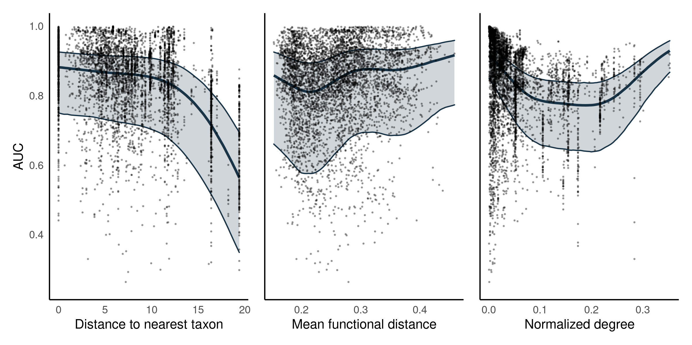Figure 3: ***Predicting species interactions****.*

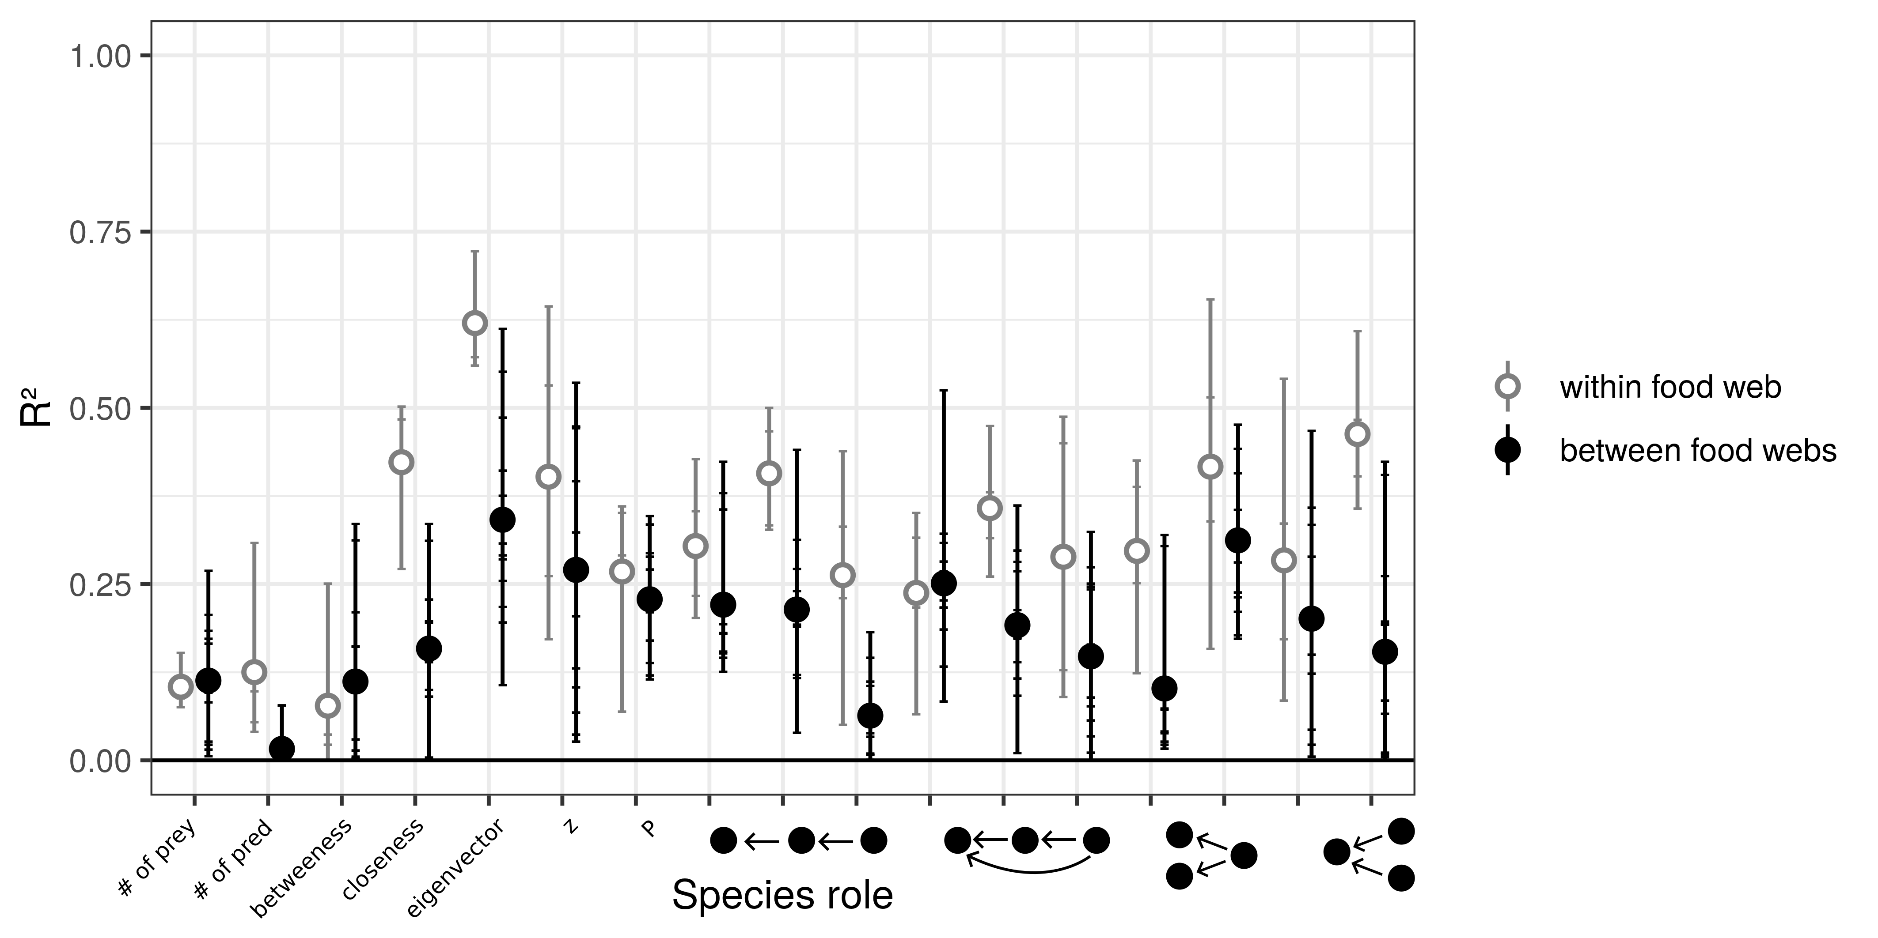Figure 4*:* ***Predicting species functional role****.*

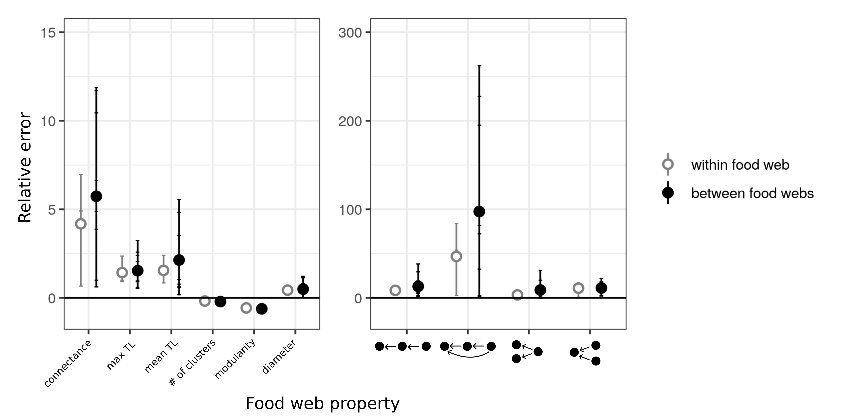Figure 5*:* ***Predicting global food web properties****.*